Temasek Polytechnic
School of Informatics and IT

Diploma in Information Technology (IT)

Project Plan

Project Particulars

Tutor | Ms Ho
Class | P01
Project Title | Delonix Regia Hotel Management System

Project Team’s Particulars

Matric Number | Student Name
1405643F | Raymond How
1400465I | Yan Jia Chen
1401314H | Siti Nadirah

Revision History

Date | Version | Description | Author
03/05/16 | 1.0 | Project Draft | Raymond
11/05/16 | 1.1 | Project Final | Raymond, Nadirah, Jia Chen

Contents
1 Introduction 4
1.1 Objectives and scope of the project 4
1.2 Assumptions and constraints 4
1.3 Definitions and acronyms 4
2 Roles and responsibilities 5
3 Estimates and project schedule 6
3.1 Work breakdown structure 6
3.2 Project Schedule 10
3.3 Budget Summary 13
4 Risk Management Plan 13
Risk Management Strategy 13

Project Plan

1 Introduction

1.1 Objectives and scope of the project

The objectives of this project is to help Mr. and Mrs. Wang design and produce a front desk system which help Mr. and Mrs. Wang to improve the front desk service provide for hotel customer. This system need to include the flowing feature check in and check out service for the hotel customer. Guest billing history witch allow the user to see the billing record. System include passport detail witch allow the user to record the passport information for the customer. The user able to see the room statistics through the room statistics report of the system. Transaction will be easily view though the transaction of the day feature.

1.2 Assumptions and constraints

Assume that Mr. and Mrs. Have no even the basic IT hardware and software that require for the system. The system design need to start from the basic set up. Include the software and hardware set need to be include part of the project.

1.3 Definitions and acronyms

SDLC: Systems Development Life Cycle
SOP: Standard Operation Procedure
RMMM: Risk management, mitigation and monitoring
BRD: Business Requirement Documentation
UI: User Interface
RAD model: Rapid Application Development model

2 Roles and responsibilities

Member | Roles
Jia Chen | - Objectives and scope of the project  - Assumptions and constraints  - Budget Summary  System features  - Cashier report  - Guest billing report  - Transaction of the day
Siti Nadirah | - Project schedule  - Roles and responsibilities  - Definitions and acronyms  System features  - Passport Details  - Information Billing  - Room Statistics Report
Raymond | - Project schedule  - Work breakdown structure  - Risk Management Plan  System features  - Check in  - Check out  - Room status

3 Estimates and project schedule

3.1 Work breakdown structure

Name | Task
Yan Jia Chen, Siti Nadirah, Raymond How | Project Initiation  Interview Client  - Identify project needs  - Plan Interview  - Conduct Interview  - Feedback from client during interview  - Jot down notes on what is required during the interview.  Team kickoff Meeting - Project goals, roles and responsibilities  - Project kickoff meeting agenda and Guidelines  - Team Member Introduction  - Aligning and adapting to partner perspective.  - Team roles and responsibilities list  - Project Team organisation and assignment  - Responsibility allocation matrix  - Software release team member glossary  Communication- with team and stakeholders/Client  - Establishing standard operation procedure (SOP) for Risk Management  - Do a Risk Management Plan and RMMM  - Write a Communications Plan  - Project Stakeholder/Influencer Assessment and communication plan  - Stakeholder Analysis summary table  - Team Meeting Descriptions Sample  - Team Meeting Agenda  - Team Meeting Minutes  Requirements - Details of what must be created  - New System Request for proposal outline  - IT Project request for proposal  - RFP for Training Programme Development  - Software Requirement specification  Scope  - Documenting Project Assumptions and Constraints  - Business Process Modelling Technique Brief  Develop a project charter  - Send project charter to client  - Client review progress of project charter  - Client authorised the project charter by signing it.
Yan Jia Chen, Siti Nadirah, Raymond How | Requirement Gathering  - Identify Project Objective  - Gather facts  - Get ideas  - Prepare a Business Requirement Documentation(BRD)  - Review BRD with client  - Revise BRD  - Confirm BRD  Analysis  - Research on affiliated or competitor corporation  - Incorporate new findings to be implemented  - Distinguish obstacles  - Search for solution  - Identify programs and equipment needed  - Place all procurements  - Monitor project progression and staffs  - Test project usability  - Consult project manager for approval
Yan Jia Chen, Siti Nadirah, Raymond How | System design  - Interface Protocol Document  - Design End User Interface(UI)  - Coding Review Guidelines  - Review Meeting Planning Worksheet  - Detailed Design Review  - Final Design Review  - Present UI versions to project manager for approval  Development  - Buy development software and tools  - Develop the software  - Monitor project progression  - Development Tracking  - Project Progress Checklists for client and project Managers  - Debug software  - Software Development Life Cycle Overview
Yan Jia Chen, Siti Nadirah, Raymond How | Software and Hardware Testing  - Integration test  - Database testing  - Usability testing  - User acceptance test  - Trial and error test  - Sign off user acceptance test  - Project Overview Test Plan  - Project Test Plan  - Software Unit Test Plan and Report Guidelines  - System Test Plan  - Software Integration Checklist
Yan Jia Chen, Siti Nadirah, Raymond How | Project Closing  Signing of Deliverables  - Check to ensure the right amount is delivered.  - Ensure that the items are not defective.  - Sign the deliverables receipt.  Describe Major Project Changes and its Effects  - Collect what are the major project changes.  - Find out why these changes was implemented.  - Explain the effects of all the changes made.  Gather Feedback from Tester  - Brainstorm the requirements for a tester.  - Let the tester use all the features of the system.  - Compile any problems, glitch and bug of the system.  Discuss Issues for Improvement  - Gather the problems encountered by the testers.  - Brainstorm possible solutions.  - Think of any possible feature addition.  Provide Recommendations  - Review the entire system.  - Identify any weaknesses.  - Brainstorm possible improvement.  - Discuss how to implement these improvements.  Announce Completion of Project  - Ensure that all the equipment’s are up and running.  - Make sure that the system has been running without any problems for a set of time.  Evaluate Project Success  - Decide if the project finished on time or in advanced.  - Make sure the project stayed in budget.  - Find out if client feedbacks are great.  - Discuss about any other success criteria.

3.2 Project Schedule

The images here are screenshot of the project schedule. Please refer to the softcopy for the full ghantt chart.

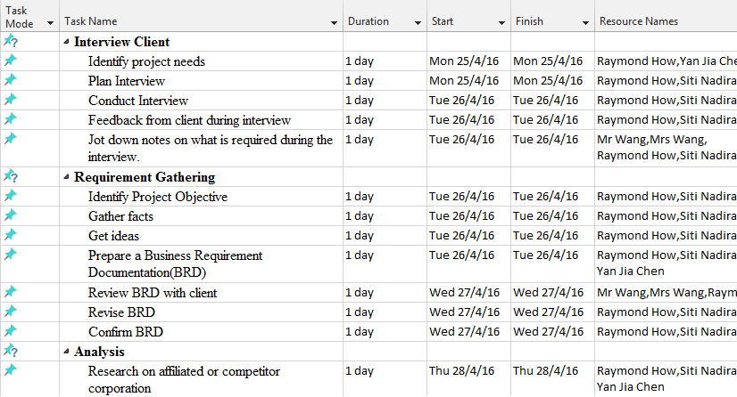

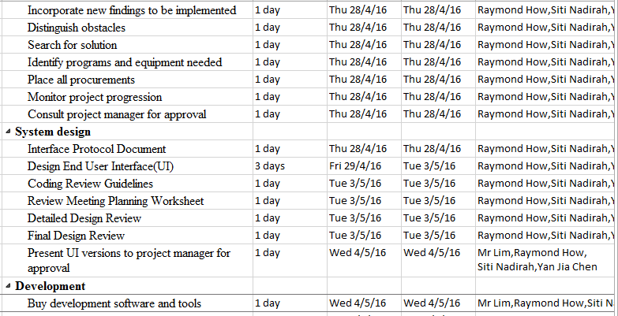

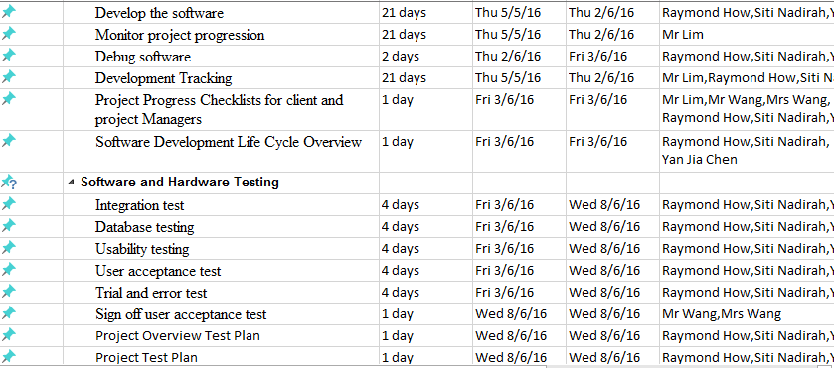

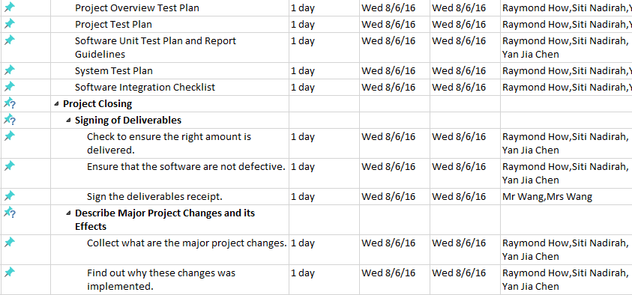

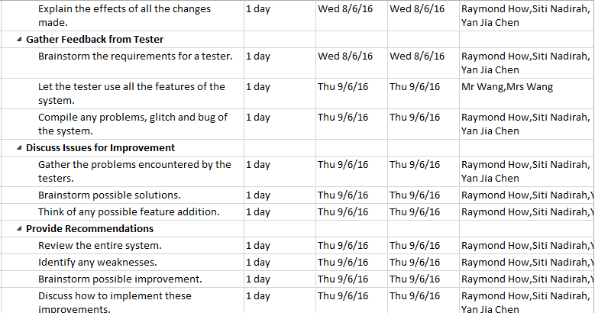

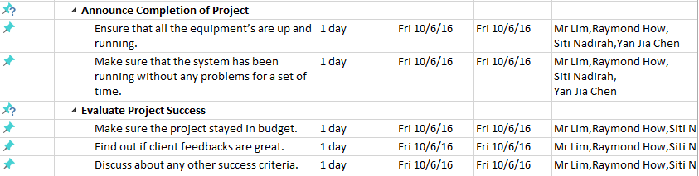

3.3 Budget Summary
Year: | 2016
 |  |  | Total
Project Expenditures | Price | Items | $
Software costs
Application software user licences | 1,000 |  | 1,000
Office 365 for business | 108 |  | 108
Database user licences | 5,000 |  | 5,000
Hardware costs
Dell optplex 3020 | 1,035 | 3 | 3,105
Printers & Scanner | 1,000 | 1 | 1,000
Back up devices | 2,000 | 1 | 2,000
Disk storage | 3,000 | 1 | 3,000
Database Server | 15, 000 | 1 | 15,000
Network costs
Cabling or wireless LAN, WAN or other network | 2,000 | 1 | 2,000
Internet access eg ADSL / broadband, satellite | 2,000 | 1 | 2,000
Manpower costs
Interns Allowances | 900 x 3 months | 3 | 8,100
Project cost calculations
Total project cost |  |  | 42,313

4 Risk Management Plan

Risk Management Strategy

Reactive Risk strategy

- Monitor the project as the project is on-going for any possible risk
- Set aside resources to deal with risk when they become actual problem
- The software development team does nothing about the risk until something goes wrong. Then the team attempts to correct the problem. This is called firefighting mode.

Proactive Risk strategy

- Better than reactive risk strategy
- Begins long before technical work is initiated
- Potential Risk are identified, their probability are accessed and ranked by importance

Risk Table
Risk | Category | Probability | Impact
Late Delivery | BU | 30% | 1
Larger number of user than planned | TI | 70% | 1
End user resist system | BU | 20% | 1
Changes in Requirement | PS | 20% | 2
Lack of Database Stability | TI | 40% | 2

Impact Values

1 – Catastrophic
2 – Critical
3 – Marginal
4 – Negligible

Category abbreviation

BU – business impact risk
PS – process definition risk

Risk Mitigation, Monitoring and Management

Risk: Late Delivery

Mitigation

The cost associated with a late delivery is critical. A late delivery will result in a late delivery of letter of acceptance from the customer. Without the letter of acceptance, the group will receive a failing grade for the course. Steps have been taken to ensure a timely delivery by gauging the scope of project based on the delivery deadline.

Monitoring

A schedule has been established to monitor project status. Falling behind schedule would indicate a potential for late delivery. The schedule will be followed closely during all development stages.

Management

Late delivery would be a catastrophic failure in the project development. If the project cannot be delivered on time the development team will not pass the course. If it becomes apparent that the project will not be completed on time, the only course of action available would to request an extension to the deadline from the customer.

Risk: End Users Resist System

Mitigation

In order to prevent this from happening, the software will be developed with the end user in mind. The user-interface will be designed in a way to make use of the program convenient and pleasurable.

Monitoring

The software will be developed with the end user in mind. The development team will ask the opinion of various outside sources throughout the development phases. Specifically, the user-interface developer will be sure to get a thorough opinion from others.

Management

Should the program be resisted by the end-user, the program will be thoroughly examined to find the reasons that this is so. Specifically, the user interface will be investigated and if necessary, revamped into a solution.

Risk: Change in requirement

Mitigation

In order to prevent this from happening, meetings (formal and informal) will be held with the customer on a routine business. This ensures that the product we are producing, and the specifications of the customer are equivalent.

Monitoring

The meetings with the customer should ensure that the customer and our organization understand each other and the requirement for the product.

Management

Should the development team come to the realization that their idea of the product specifications differs from those of the customer, the customer should be immediately notified and whatever steps necessary to rectify this problem should be done. Preferably a meeting should be held between the development team and the customer to discuss at length this issue.

Risk: Database is not stable

Mitigation

In order to prevent this from happening, developers who are in contact with the database, and/or use functions that interact with the database, should keep in mind the possible errors that could be caused due to poor programming/error checking. These issues should be brought to the attention of each of the other members that are also in contact with the database.

Monitoring

Each user should be sure that the database is left in the condition it was before it was touched, to identify possible problems. The first notice of database errors should be brought to the attention of the other team members.

Management

Should this occur, the organization would call a meeting and discuss the causes of the database instability, along with possible solutions.

